Tutorial 4:

Hi, welcome back. How are you? Are you able to understand everything well? Don’t forget we have a manual, everything learned in this tutorial can be found as a reference in there.

**How do posvalwtype and posvalhtype work?**

This has about the same basic options as posinframex/y.

Here is a list:

-px: gives a width or a height in pixels.

-dp: gives a width or a height in inches.

-fc: gives a width or height relative to the parent’s size.

Setting a value for posvalwtype and posvalhtype will affect how the variables posvalw and posvalh work.

EXAMPLE 14:

[CODE]

//create event of a newly created object.

//initialize uiz

uiz_init()

//create our square object

square=uiz_c(obj_uiZ_square)

//setup some variables

square.posinframex=fc;

square.posinframey=fc;

square.posvalx=0.3;

square.posvaly=0.6;

square.posvalwtype=fc;

square.posvalhtype=fc;

square.posvalw=0.3;

square.posvalh=0.1;

//fix our square object.

uiz_fixgeneralpos(square)

[/CODE]

IMAGE 15

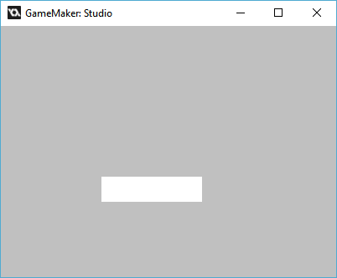

IMAGE 16:

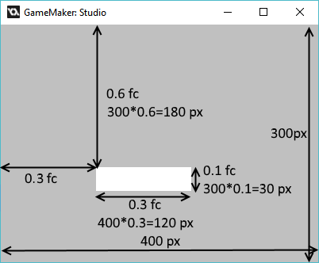

Here we are defining the left top point of the object, but what if we don’t want that?

We can set the variables “posvalx” and “posvaly” for that. The top-left position would be set using:

[CODE]

Square.posvalx=uiz_left

Square.posvaly=uiz_top

[/CODE]

Setting the right bottom would be:

[CODE]

Square.posvalx=uiz_right

Square.posvaly=uiz_bottom

[/CODE]

“Do I need to set those variables?” you ask? Well, no you don’t. By default setposx and setposy are set to uiz_auto. If these values are set to uiz_auto then it will automatically pick a position in the object that fits the posinframex or posinframey the best. For example, for uiz_snapright, it will automatically pick a value of uiz_right for posvalx.

I hope you got what posvalx and posvaly does. How you can use this in reality will come to use when you start to code and use uiz in your projects.